UConn 4-H Horse Program
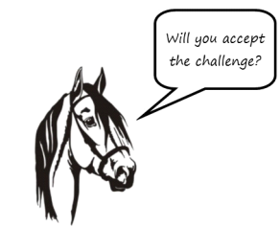
Equine Poster Challenge
May 6, 2023
Middlesex County Extension Center – Haddam CT

The Mission:
To create an attractive and informative poster to educate horses show spectators & participants. The poster may illustrate any topic related to equine species.
The Details:
- The CT 4-H Horse Show Committee challenges any 4-H members aged 7-19 to enter this contest.
- There will be a separate division for Explorers; ages 5 and 6.
- Contestants do not need to have a horse project to enter.
- Posters must be at the CT 4-H Horse Activity Day before 10:00 a.m. on Saturday May 6, 2023.
- Poster must have been made during the current 4-H year and must be the member’s own work.
- Poster should be no less than 14” x 22” and no more than 22” x 28”. They should be two-dimensional,
eye-catching, informational art.
- Posters should NOT be a booth board or a science project.
- To enter, complete the lower portion of this form and send via email to Emily.alger@uconn.edu by
May 1, 2023.

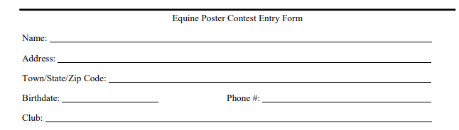

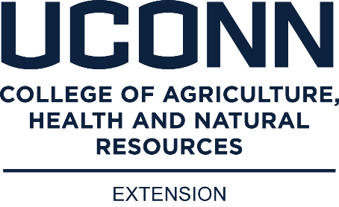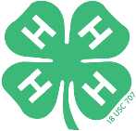

(1-2023) The University of Connecticut complies with all applicable federal and state laws regarding non-discrimination, equal opportunity and affirmative action, including the provision of reasonable accommodations for persons with disabilities. UConn does not discriminate on the basis of race, color, ethnicity, religious creed, age, sex, marital status, national origin, ancestry, sexual orientation, genetic information, physical or mental disability, veteran status, prior conviction of a crime, workplace hazards to reproductive systems, gender identity or expression, or political beliefs in its programs and activities. Employees, students, visitors, and applicants with disabilities may request reasonable accommodations to address limitations resulting from a disability. For questions or more information, please contact the Associate Vice President, Office of Institutional Equity, 241 Glenbrook Road, Unit 4175, Storrs, CT 06269-4175; Phone: (860) 486-2943; Email: equity@uconn.edu; Website: equity.uconn.edu.

