Giddy Up Games
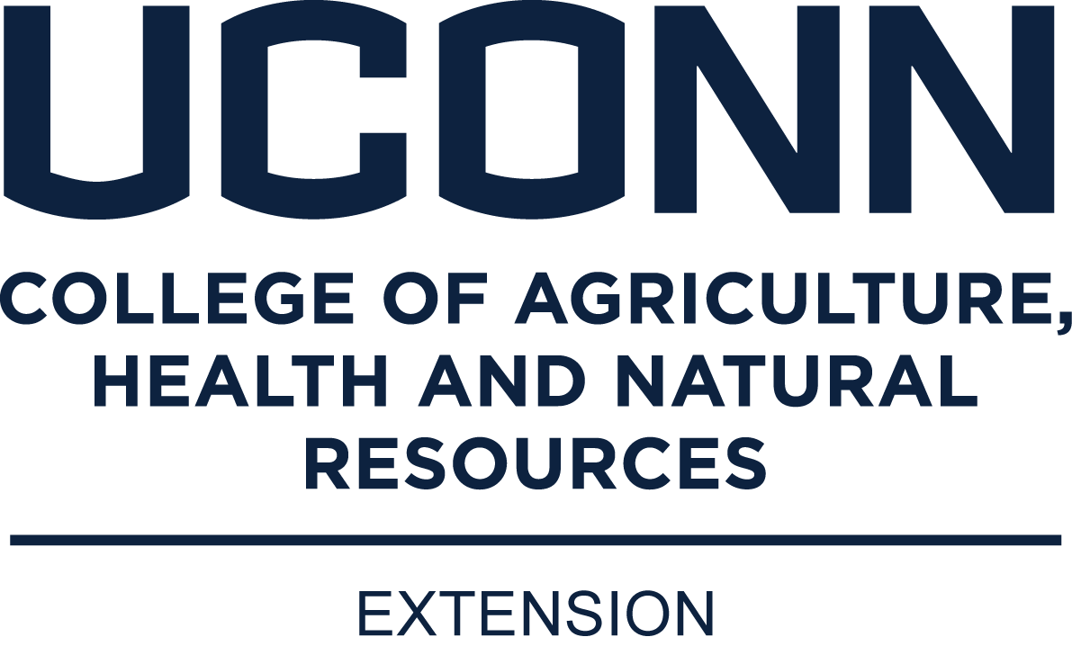
May 6, 2022
9:30 a.m.
UConn Middlesex Extension Center
Please fill out form by April 28, 2023

We will again have Giddy Up Games in 2023! We are so very excited to see everyone! This event is free of charge but registration in advance is required. Email your form to emily.alger@uconn.edu and Jenifer.nadeau@uconn.edu

For those new to the program, Giddy Up Games is a fun interactive program where teams of 2 participate in horse-themed challenges and win prizes at the end of the day! There are two levels of participation, beginner and advanced. Your age does not matter as you can self-select your team’s level.

Please bring your own writing implement and clip board. We will likely need help this day – so idle parents/leaders should check in upon arrival to see if they can help.

If you are also doing Model Horse Show or Poster Contest, please follow the instructions and come well in advance (9:00 a.m.) to set up your displays.
******************************************************************************************
Giddy Up Registration Form – due April 28, 2023

Team 4-H Member 1 –
Name Email County

Team 4-H Member 2 –
Name Email County

Division (circle one)
Beginner Advanced

Parent names and how you are willing to help (we will definitely need many helpers)
Name Email

*helpers please arrive at 9:15 a.m. for instruction and assignment

(1-2023) The University of Connecticut complies with all applicable federal and state laws regarding non-discrimination, equal opportunity and affirmative action, including the provision of reasonable accommodations for persons with disabilities. UConn does not discriminate on the basis of race, color, ethnicity, religious creed, age, sex, marital status, national origin, ancestry, sexual orientation, genetic information, physical or mental disability, veteran status, prior conviction of a crime, workplace hazards to reproductive systems, gender identity or expression, or political beliefs in its programs and activities. Employees, students, visitors, and applicants with disabilities may request reasonable accommodations to address limitations resulting from a disability. For questions or more information, please contact the Associate Vice President, Office of Institutional Equity, 241 Glenbrook Road, Unit 4175, Storrs, CT 06269-4175; Phone: (860) 486-2943; Email: equity@uconn.edu; Website: equity.uconn.edu.

