Thank You for Your Generous Gift to the Middlesex & New Haven 4-H Fair, part of the UConn 4-H program

Name (please print clearly) _____________________________________________________________________________________

Address ____________________________________________________________________________________________________

Phone ____________________________________________ Email _________________________________________________
□ Please accept our contribution of □$250 □$500 □$1000 □$
Sponsorships turned in by March 1, 2023 will receive the recognition listed above

□ CHECK. Please enclose a check made payable to Middlesex & New Haven County 4-H Fair
□ VENMO
□ I will submit the required forms to my employer so that my gift will be increased with a matching gift
All donation levels are welcome! Support financially or word of mouth is appreciated and will allow us to hold a 4-H fair this year.
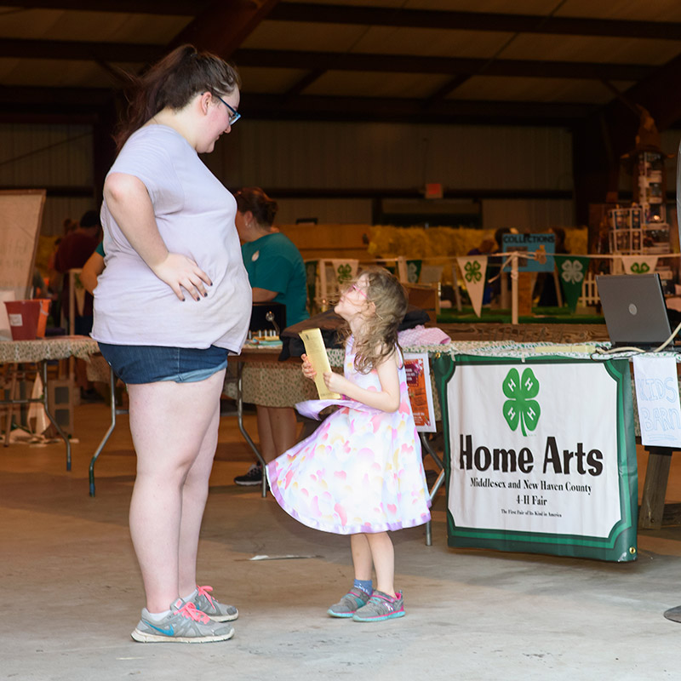
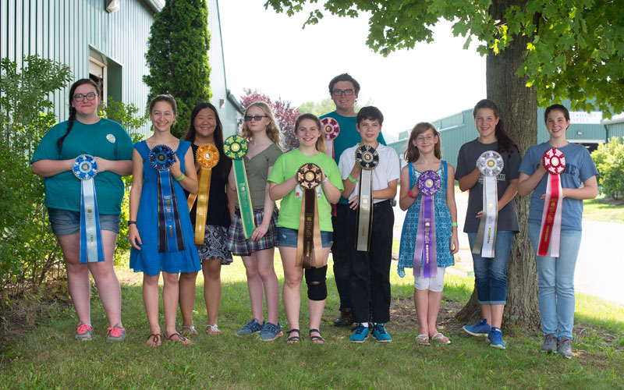

If you would like to be a business sponsor of our 4-H fair, please see the following details.
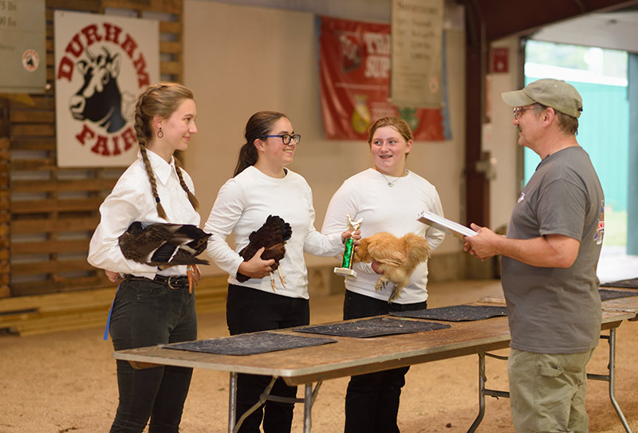
$250 Sponsor
- Your logo/business information on our event posters and signage for the full fair weekend
$500 Sponsor
- Everything from previous level and
- County 4-H Facebook posts about your business and generous donation during the week of the fair
$1000+ Sponsor
- Everything from previous levels and
- Additional high visibility signage during events
-
HOW TO DONATE
VENMO OR CHECK
Complete and return the form below
VENMO US @Middlesex-New Haven
Please include your name, email, and specify "2023 MidNh sponsorship Campaign" in the " What 's it for?"
field, so we can send you a donation receipt - Contact Nathan Sandoval, 4-H Fair Treasurer Mentor with
questions about VENMO or tax deductions - Sandoval.nathan@gmail.com or 203-751-0036.
Checks can be mailed to the following address:
Middlesex County Extension Center
Attn. MX & NH 4-H Fair
1066 Saybrook Rd., Haddam, CT 06438

May we have permission to acknowledge your gift in 4-H communications and external publicity? □Yes □No

- Logo/Business on the back of Officer/mentor t-shirts worn throughout the fair weekend

