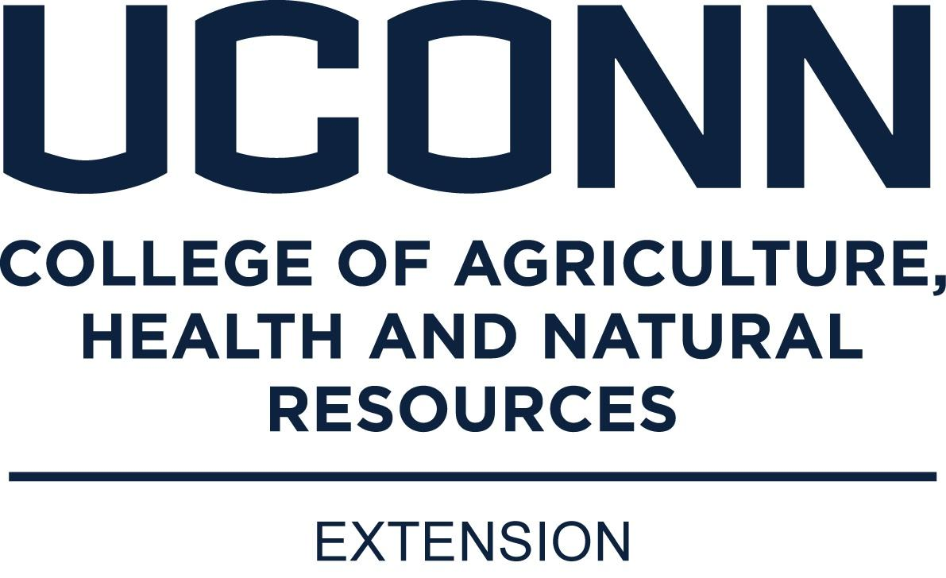
UConn 4-H Dairy and Beef Day
March 11, 2023
Registration deadline: February 17, 2023
Registration Form (Use one per family)
All participants, youth and adult must pay the registration fee of $10.00 (covers cost of program fees and t-shirt)
T-shirts will be available for both youth and adults. Anyone wanting a t-shirt must pay the $10.00 registration fee by the February 17th registration deadline, no extras will be ordered

Name/Email:___________________________________________________________ Age: ____Size:_____ Dairy or Beef
Name/Email:___________________________________________________________ Age: ____Size:_____ Dairy or Beef
Name/Email:___________________________________________________________ Age: ____Size:_____ Dairy or Beef
Name/Email:___________________________________________________________ Age: ____Size:_____ Dairy or Beef
Name/Email:___________________________________________________________ Age: ____Size:_____ Dairy or Beef
Address:____________________________________________________________________________________
City/Town:_______________________________________________ State:______________________________
Phone Number:__________________________________Email:_______________________________________
*Please bring a gift basket or item for the silent auction to help raise funds for this event!
*4-H Project: Please make sure to list your project area above (dairy or beef) so that we can split you into the appropriate groups where needed.
Lunch will be on your own. We will have a list of restaurants on campus available for you as well that day.
To register please send completed form and registration fee (make checks payable to LCCESA ) to: Bill Davenport, 843 University Drive, Torrington, CT 06790, email William.davenport@uconn.edu, Phone 860-459-6753.
All youth must be accompanied by parent/guardian or chaperon.
Health Forms for Youth Not Accompanied by Parent
If a parent or guardian will not be accompanying a youth participant to 4-H Dairy and Beef Day, the chaperon accompanying the youth must have a 4-H Member/Volunteer health form ( healthform4h) in his or her possession for each participating member not accompanied by a parent or guardian. The health form must be signed by the youth’s parent or guardian.
UConn complies with all applicable federal and state laws regarding non-discrimination, equal opportunity, affirmative action, and providing reasonable accommodations for persons with disabilities. Contact: Office of Institutional Equity; (860) 486-2943; equity@uconn.edu; http://www.equity.uconn.edu.

2023 UCONN 4-H DAIRY/BEEF DAY
Sponsored by Farm Credit East
March 11, 2023 9:00 am to 3:00 pm
UConn Ratcliffe Hicks Arena
- 8:30 to 9:00 am
  - Check-In: RH Arena
- 9:00 to 9:05 am
  - Welcome: Bonnie Burr
- 9:05 to 9:30 am Farm Safety Presentation

Morning Sessions in RH Arena

- 9:30 to 10:00 am (30 minutes each)
  - Beef Cattle Judging (Beef members go to beef barn)
  - Purchasing Dairy Cattle and Understanding Pedigrees (Dairy members stay in RH arena)

- 10:15 to 11:50 am (20 minutes each ) (dairy and beef combined)
  - A.I. Tracts, Tools and A.I. Simulator
  - Digestive Tract
  - Meat Cuts ID
  - Carcass Evaluation (ultrasounding live beef cattle in a chute) outside RH arena

- 11:50 am to 1:00 pm LUNCH on your own (a list of area restaurants will be available that day)

Afternoon Sessions in RH Arena
- 1:00 pm to 2:30 pm

Workshops in RH arena: (dairy and beef combined)
  - Agriculture Career Exploration Panel Discussion (large classroom upstairs, high school aged members)
  - Halter making (younger members)
  - Tattoo practice on cow ears (younger members)
  - Animal First Aid Kits (what to have with you at a fair or in your barn)
  - Off-flavors in milk

2:45 pm: wrap up and evaluation session, silent auction results

NOTE: Gift Basket Silent Auction will take place during this event to help raise money for expenses
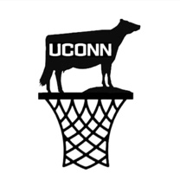
The UConn Dairy Club is holding the UConn Spring Tip-Off Dairy Calf Sale on 3/11/23 starting at 3pm. RH Arena will be set up for bidding in the virtual sale. Any Dairy/Beef Day participants and parents are welcome to go and view the sale!

