**Connecticut State 4-H Horse Show**

**2022**

**Pattern Book**

1. Junior Novice SE Fitting and Showmanship
2. Senior Novice SE Fitting and Showmanship

23. Novice Junior Fitting and Showmanship

24. Senior Novice Fitting and Showmanship

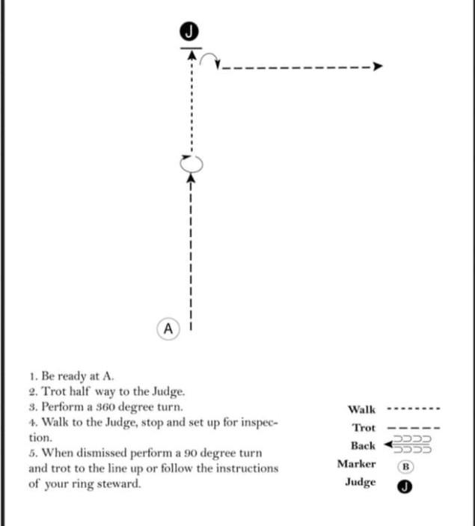

1. Junior SE Fitting and Showmanship

25. Junior Fitting and Showmanship

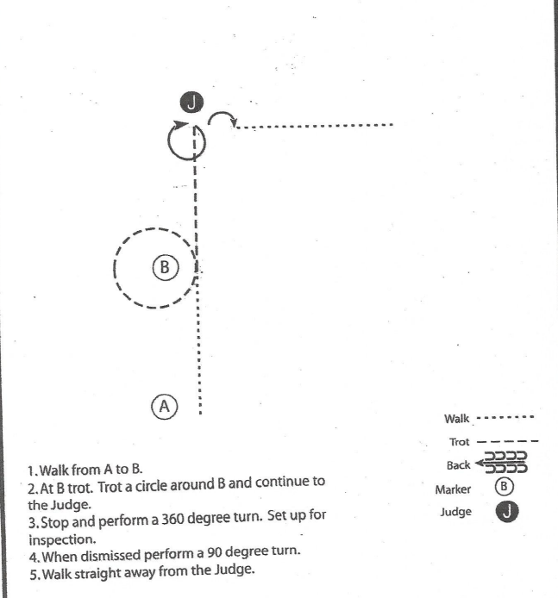

4. Senior SE Fitting and Showmanship

26. Senior Fitting and Showmanship

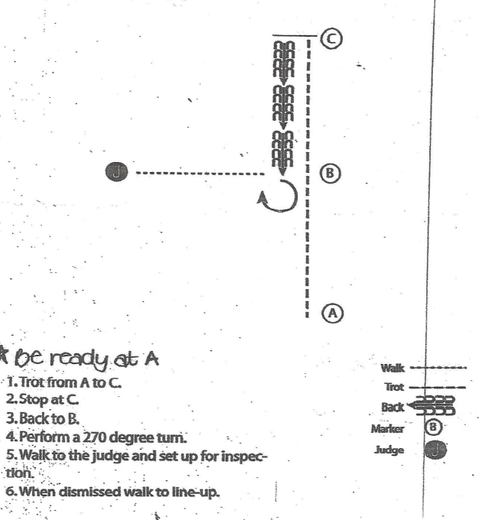

10 & 11 – Small Equine In Hand Hunter

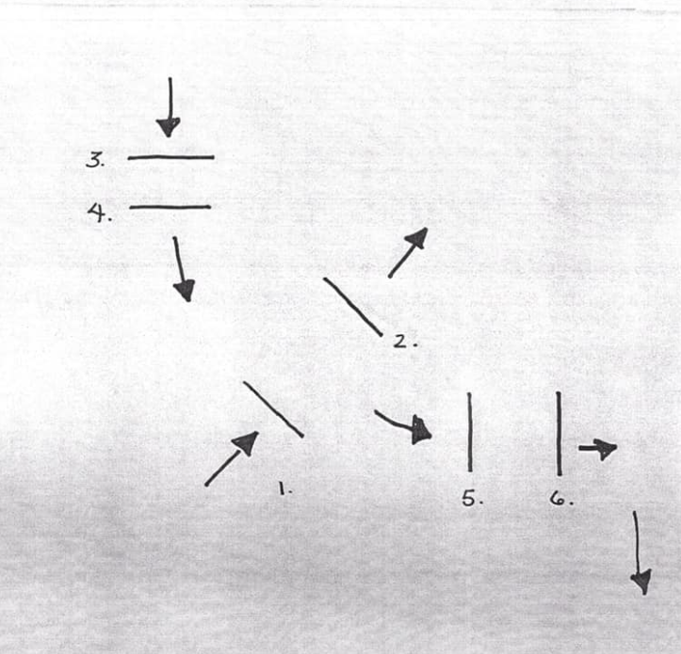

12 & 13 – Small Equine Jumpers

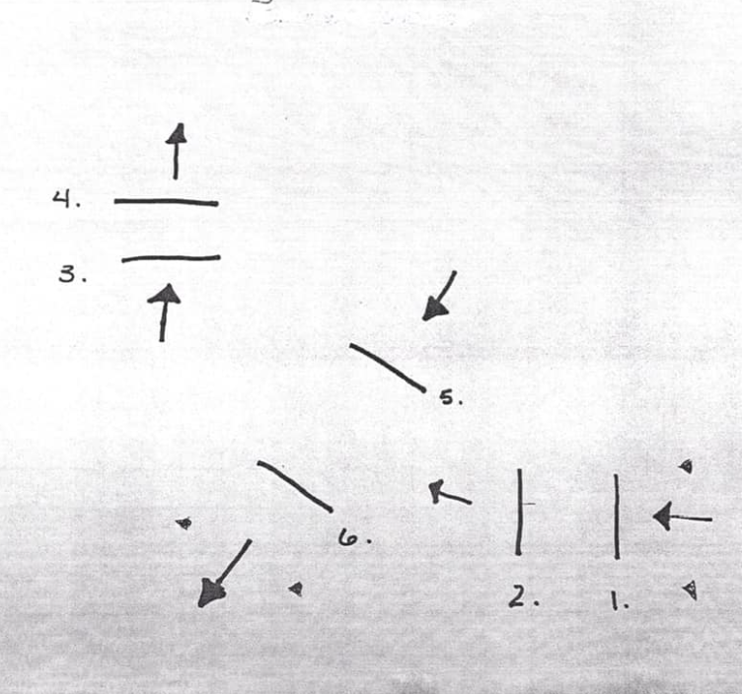

14. & 15. Small Equine Obstacles

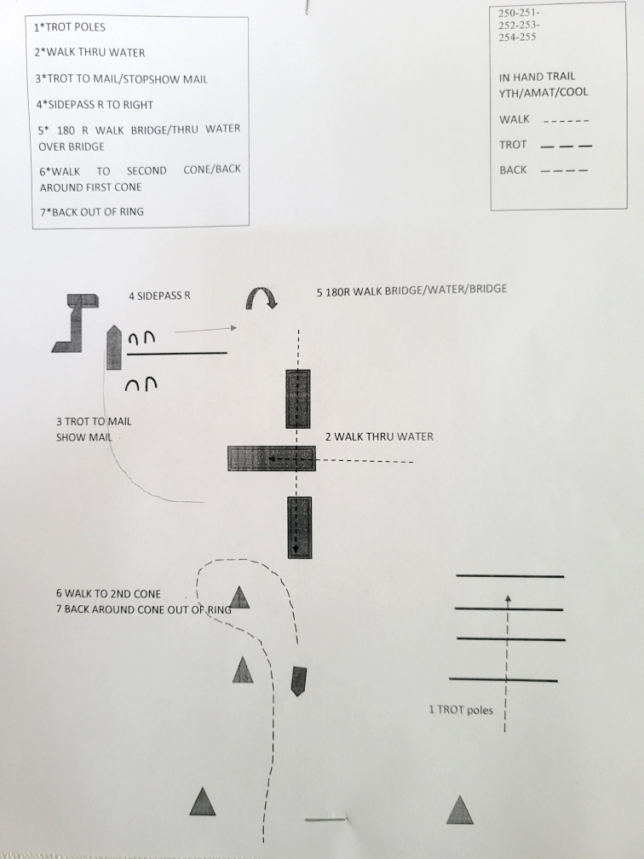

19. SE Reinsmanship

22. Reinsmanship

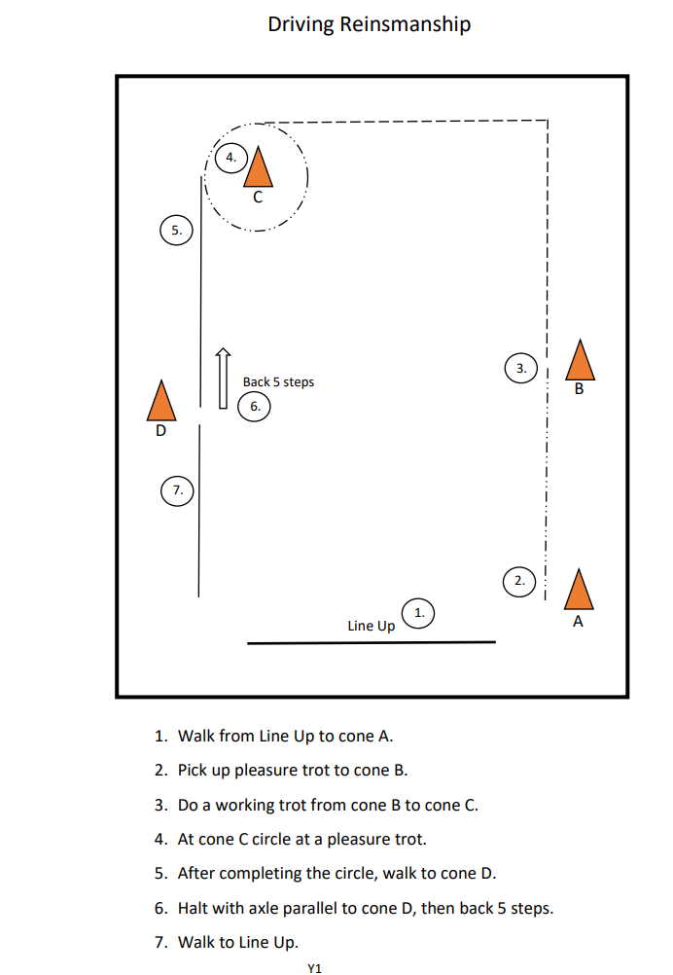

20. SE Driving Obstacles

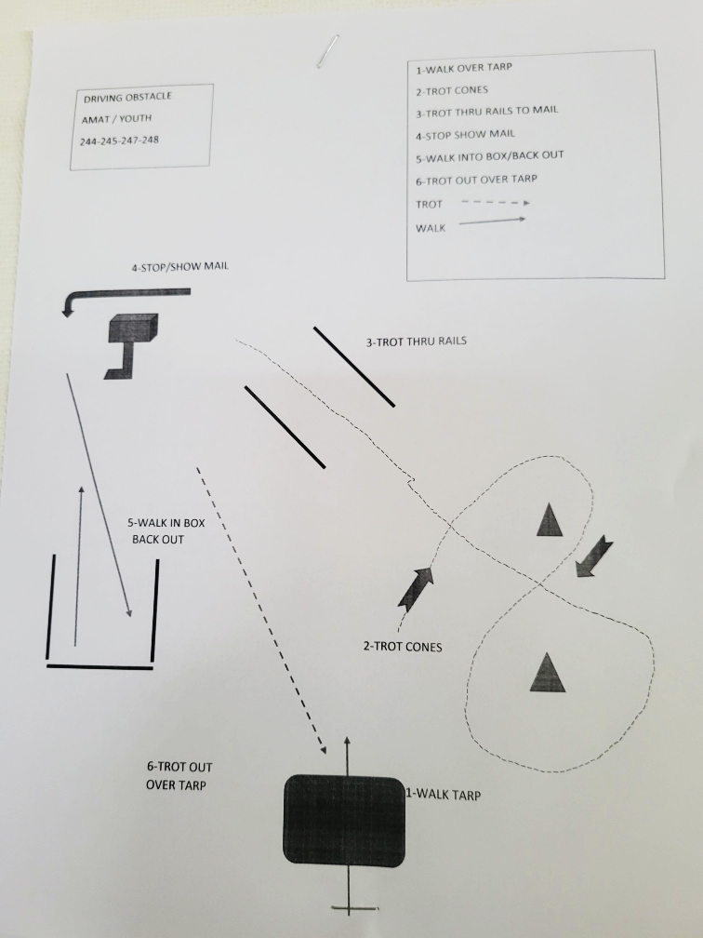

16. SE Ground Driving

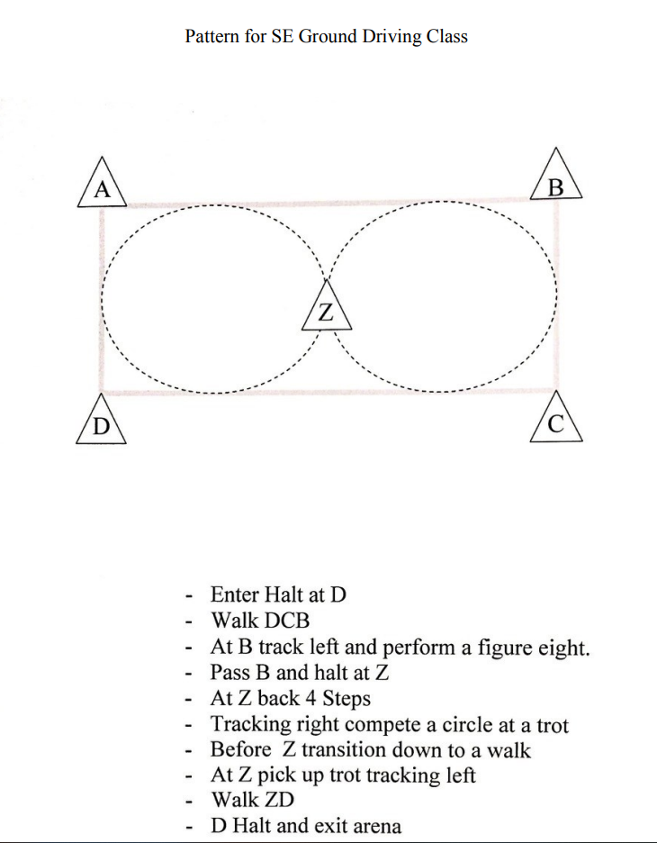

30. Junior In Hand Trail

31. Senior In Hand Trail

32. Leadline trail

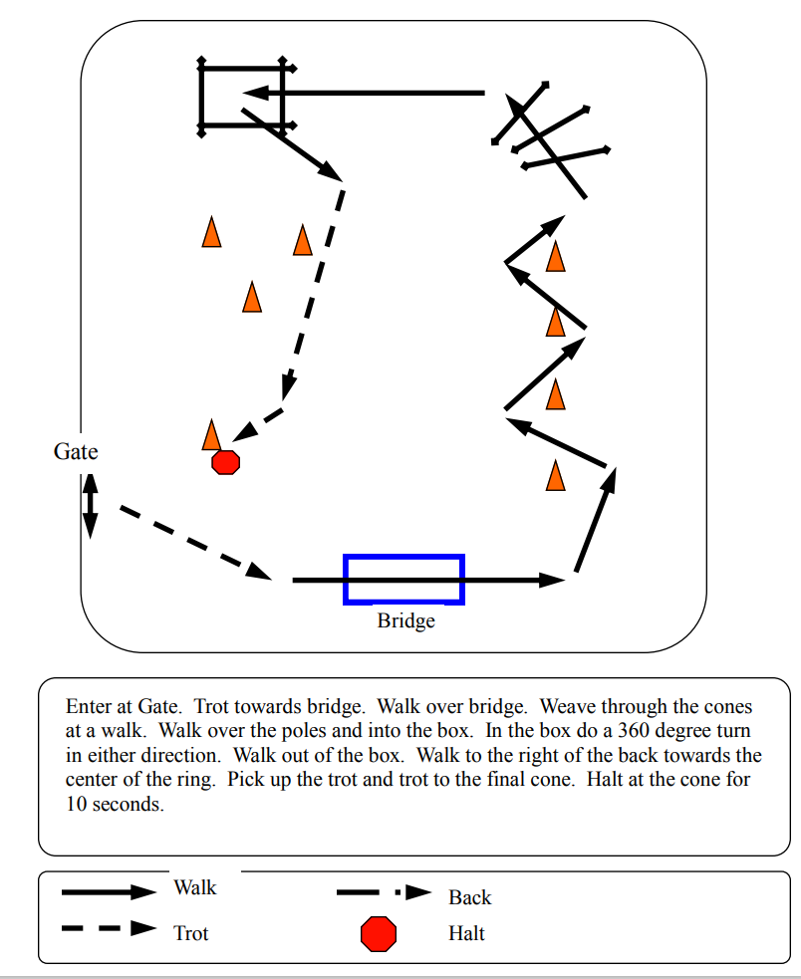

33 W/T Western Trail

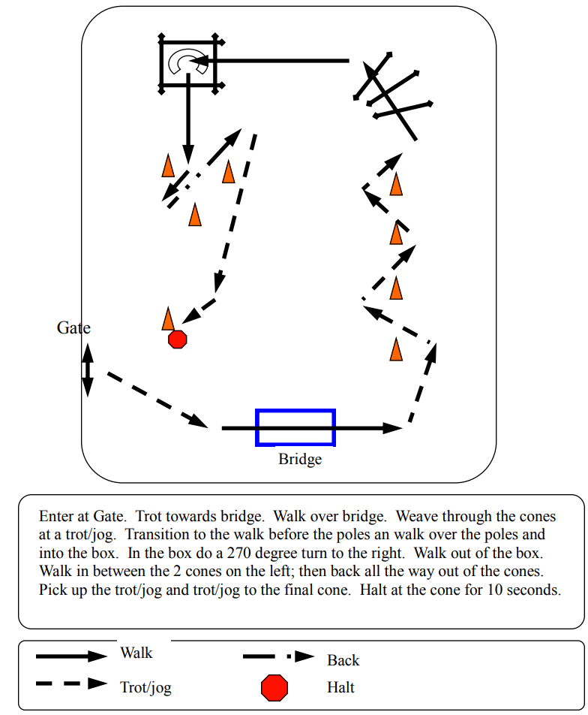

34. W/T/C Junior Trail

35. W/T/C Senior Trail

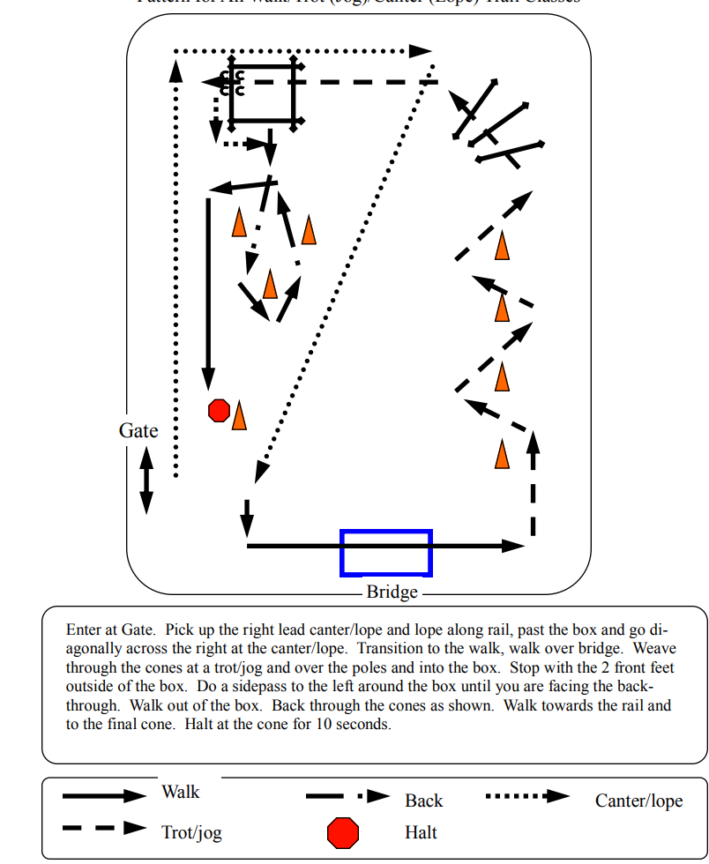

57. W/T Crossrails

58. W/T Crossrails Hunter

59. W/T/C Crossrails

60. W/T/C Crossrails Hunter

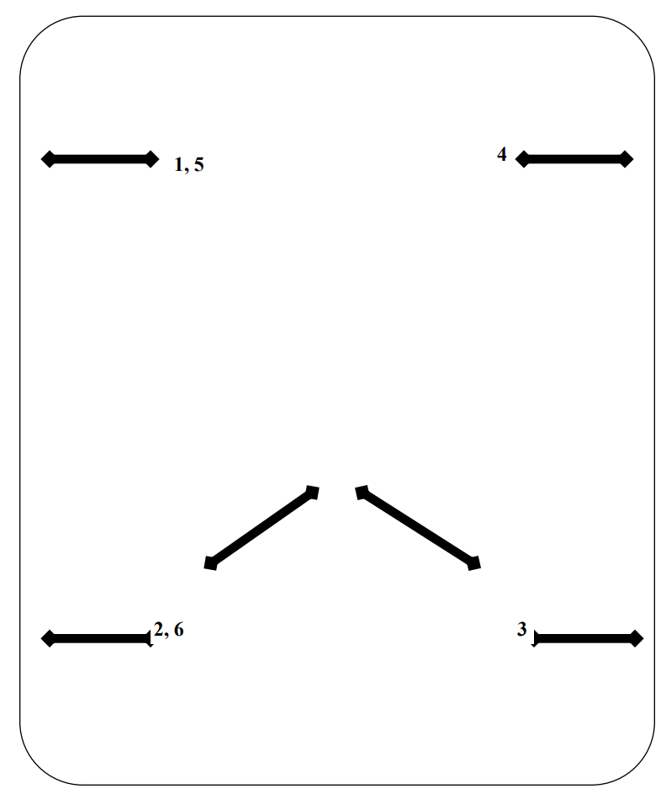

61. W/T/C Equitation Over Fences

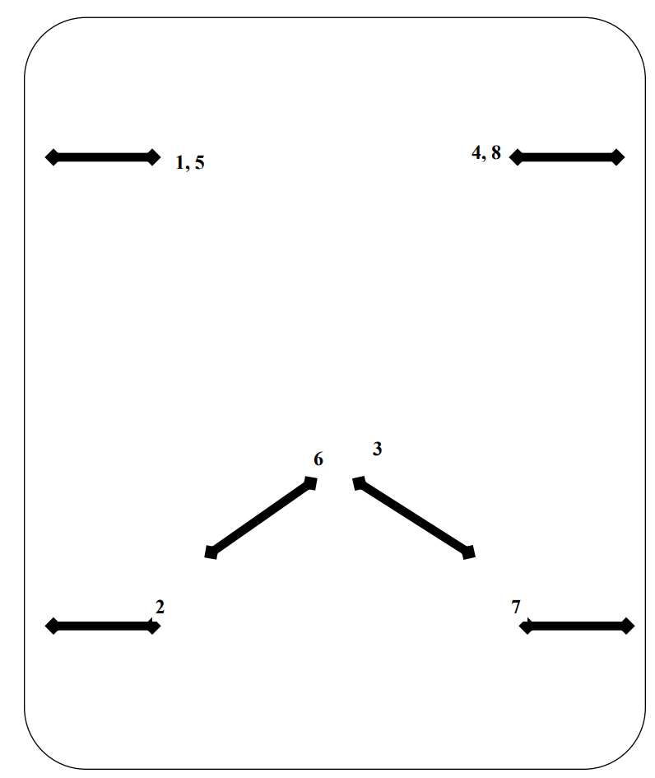

**, 6**

62. W/T/C Hunter Over Fences



**7**

**3**

**4, 8**

**2, 5**

**6**