

**Connecticut 4-H**

**Smart Shopper**

**Workbook**



Name: __________________________

Age: _______________

County: ________________________

Acknowledgements

The Connecticut 4-H Smart Shopper Workbook contains adaptations of material from Iowa, Kentucky, and the New England Consortium. Preparation of the Connecticut 4-H Smart Shopper is a collaborative effort among 4-H staff and volunteers.



Updated 3/2022

**Smart Shopper Project**

Smart Shopper is a consumer education project. The Smart Shopper 4-H project is designed to help you find out about your personal style, learn how to customize your closet, discover how to make educated clothing purchases, and properly care for items in your wardrobe.

**Requirements:**

It is important that you complete all the items in your Smart Shopper Workbook. Ask a friend, parent, or 4-H leader to assist you if you have questions.

You must purchase or acquire at least two pieces of wearable clothing and combine it with clothing you already own. Wearable clothing must be items such as a sweater, pants, shirt, skirt or other apparel. You may still purchase accessories such as jewelry, belts, or other non-clothing items; however, these items are in addition to clothing items you purchase.

You may choose to purchase an entire outfit or only a few clothing items that can be combined with other clothing you already own. In your score sheet, there are points given for recycling clothing. Recycling is defined to mean clothing already owned by you or someone else and includes clothing purchased in a second hand store.

The outfit you create from already existing wearable clothing and purchased clothing must be within the Smart Shopper Budget of $35.00. Keep your receipts; you will need to include them on the Budget page found in this workbook. Remember, your total amount includes any shipping costs for items purchased on the Internet and sales tax.

**Evaluation of the Smart Shopper Project:**

Evaluation of the smart Shopper Project will be based on several factors:

* The Smart Shopper Workbook – satisfactory completion of items listed below:
  + Title Page (on front of the workbook)
  + All About My Style
  + All About My Project
    - Shopping Plan
    - Clothing Care
    - Smart Shopper Photographs - - You must include at least one picture of yourself wearing the outfit and accessories you acquired for this project. All pictures should be labelled with the date, your name, and the articles which were purchased and which were previously owned.
    - Smart Shopper Receipts
    - Smart Shopper Experience – Your Smart Shopper Story
* Judging of Individual and Outfit:
  + Evaluation of the Smart Shopper Outfit and Workbook will take place prior to Expressive Arts Day (see Connecticut 4-H webpage for times and locations or contact your 4-H Program Specialist).
  + A copy of the evaluation form is found in the Smart Shopper Workbook for the participant’s use.
  + Judges will evaluate fit, appropriateness of outfit, and how the outfit looks on the participant. The participant will also answer interview questions

**All About My Style**

List the activities you participate in, including school, work, household responsibilities, sports, 4-H projects, and other things that you like to do.

List other clubs and organizations in which you are involved.

What type or types of clothing is needed for your activities?

What colors do you look best in? Why do you feel good in those colors?

What colors would you like to wear but don’t? Why don’t you wear them?

What do you like best about yourself?

Is there something in your closet that you are not wearing but want to? Explain what the item is and why you are not wearing it?

**All About My Project**

Have you been involved in the Smart Shopper project before? Yes _______________ No _____________

If Yes, for how many years? _________________________________________

If you have been in the Smart Shopper project before, how will you grow or develop your project this year?

For everyone: List three new things that you learned by doing this project

1.

2.

3.

**Smart Shopper Shopping Plan**

Record all the items you try on and reject as well as purchase on the chart; you can make additional copies if you need to and add them to your notebook.

|  |  |  |  |  |
| --- | --- | --- | --- | --- |
|  | *Example* | Item 1 | Item 2 | Item 3 |
| What did you try on? | *Blue and yellow shirt* |  |  |  |
| Why did you choose or reject this item? | *I needed a new shirt to wear with my new jeans.* |  |  |  |
| Are you adding to or replacing something in your closet? If you are replacing, write the name of the item you are replacing. | *Adding* |  |  |  |
| Is this a needed or a desired purchase? | *Needed* |  |  |  |
| Is this item within your Smart Shopper budget? | *Yes, $10* |  |  |  |
| List the clothing in your closet that can be work with the item you plan to purchase. | *Tan skirt, jeans, beige pants* |  |  |  |
| How often and where will you be able to wear this item? | *All year to school, out to dinner* |  |  |  |
| List the item purchased and the amount paid. | *Blue and yellow shirt. $12.58* |  |  |  |

**Smart Shopper Clothing Care**

How will the items you purchase need to be cleaned? Are they washable or do they need to be dry-cleaned? Do the colors bleed and they need to be hand washed in cold water or can they be washed with other items in the washing machine?

Complete the chart below to evaluate the care needs of the items you purchased for this project. Look at the care labels found inside the clothing. A chart about clothing care labels is found in this workbook on page 7. You can find additional information by googling ‘clothing care labels.’

|  |  |  |  |  |
| --- | --- | --- | --- | --- |
|  | *Example* | Item 1 | Item 2 | Item 3 |
| Name of item or description of item | *Green t-shirt* |  |  |  |
| List the major fiber content of this piece of clothing | *50% cotton*  *50% polyester* |  |  |  |
| What are the clothing care instructions on the label? | *Machine wash in warm, same colors, inside out, no bleach* |  |  |  |
| Does this piece of clothing have special care needs? | *No* |  |  |  |
| Why is the fiber content and clothing care important to you? | *Easy care and being able to machine wash is important to me. Cotton/polyester is easy care with no ironing needed.* |  |  |  |

**Smart Shopper Clothing Care**

**Fabric Durability**

Different types of fabric have various strengths and weaknesses. How durable is the fabric in your outfit? Fabric durability is defined as “capable of withstanding wear and tear.”

You may need to conduct some research in order to learn about the durability of the fabrics in your outfit and to complete the table below.

Some suggestions for you to use are the local library, textbooks about fabrics that might be found in a bookstore or university bookstore, or various sites on the Internet.

You will need to include the resources you used in the table below. If you used more than one resource list them all. Also note the date when you used that resource.

Please note you are required to use resources other than parents or relatives to answer this question. You can add additional boxes if needed.

|  |  |  |  |
| --- | --- | --- | --- |
|  | Name of item | Durability of fabric | Source of information |
| *Example* | *Green T-Shirt* | *Very durable as cotton and polyester are strong fibers* | *Internet site: ‘I found it here.com’* |
| Item 1 |  |  |  |
| Item 2 |  |  |  |
| Item 3 |  |  |  |

**Your Guide to Fabric Care Symbols:**

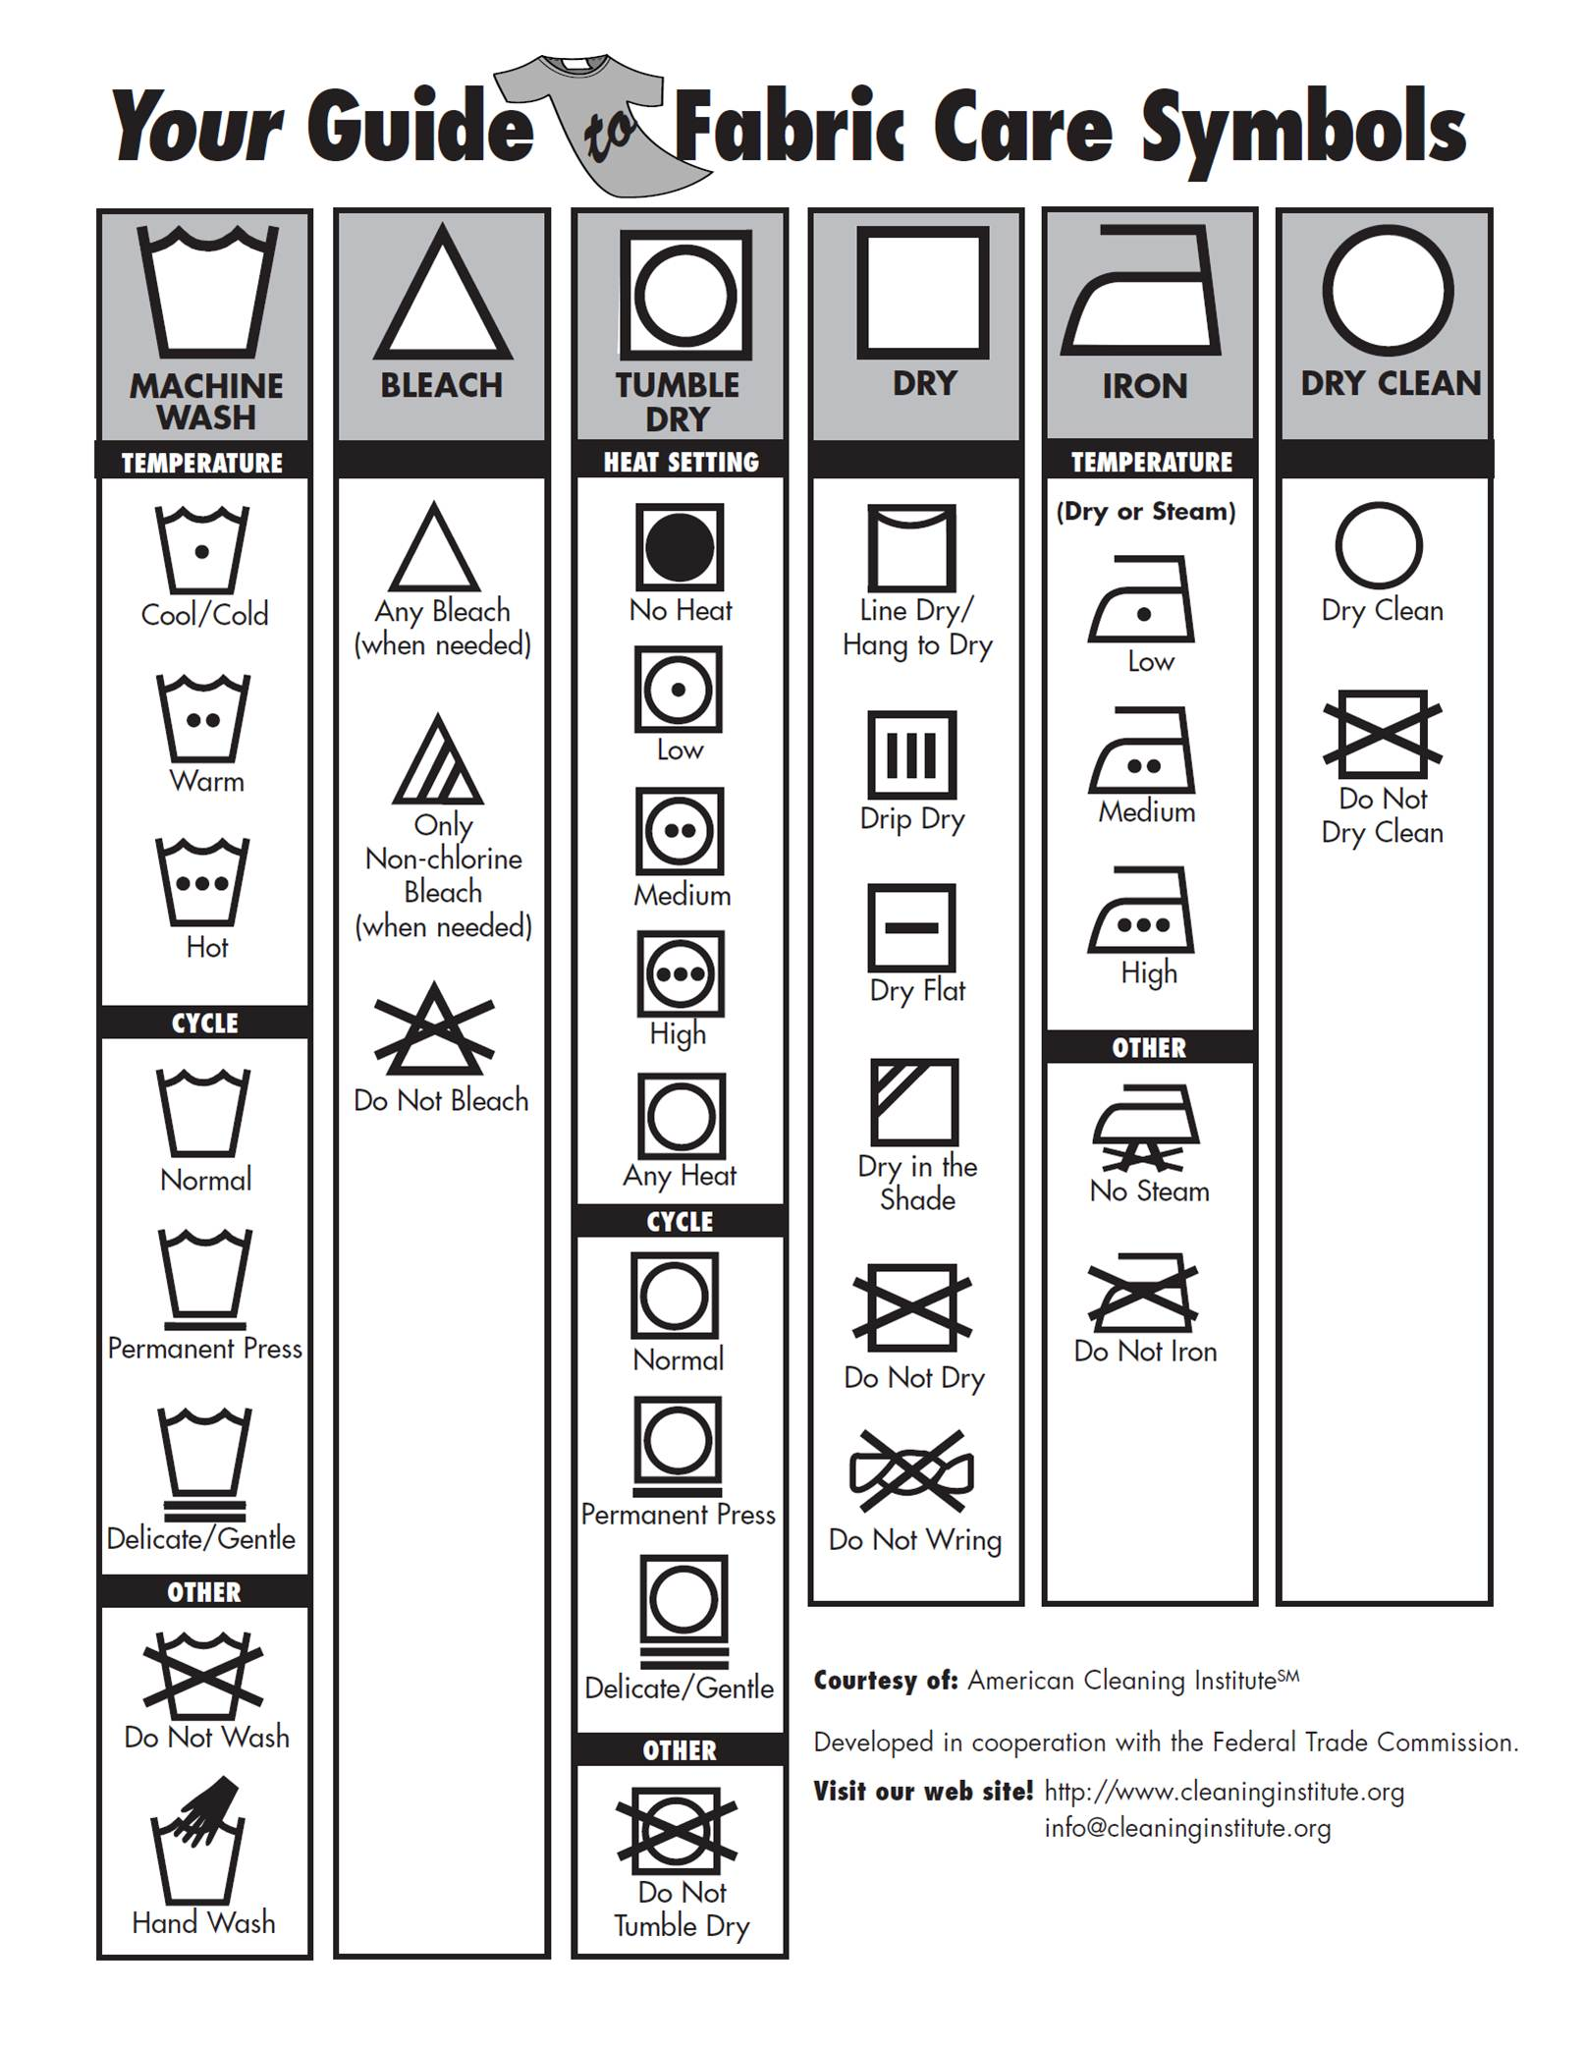

Obtained from http://www.cleaninginstitute.org/clean_living/your_guide_to_fabric_care_symbols.asp

**Smart Shopper Photographs**

On this page, include at least one photograph of yourself in the outfit you created for the Smart Shopper project. Additional photographs can be included that relate to this project. For example, you might have photos of the different items you purchased, photos of you and friends shopping, or other project related pictures. All pictures should be labeled with a date and caption. ***One of the photos must be of you wearing your Smart Shopper outfit.***

If you choose, you may create a page of digital photos (labeled) on a computer and print out that page. Please print photos in color if possible in order for your outfit to be seen to its best potential. You can insert your digital photo page into the Smart Shopper Workbook.

**Smart Shopper Project Outfit Budget & Receipts**

Attach your original receipts on this page. Make a note next to each receipt indicating what the receipt is for (example: blue and yellow shirt), and where you purchased it. If you like, you may make copies of them before turning in your workbook in case you need the information for other fashion revue paperwork.

|  |  |  |
| --- | --- | --- |
| Name or description of item | Cost of item | Other Information |
|  |  |  |
|  |  |  |
|  |  |  |
|  |  |  |
|  |  |  |
|  |  |  |
|  |  |  |
|  |  |  |
|  |  |  |
|  |  |  |
|  |  |  |
| Total Amount Budgeted: | $35.00 |  |
| Total Amount Spent:  (including sales tax and other fees) | $ |  |
| Total Amount Remaining in Budget (if any) | $ |  |

**Smart Shopper Experience**

Write a story telling what you learned in this project. You can choose whether you write this as a story or as journal entries. It is your choice. Your story must be more than 6 sentences long and must include things you learned:

* About your style
* About clothing care
* Your personal wardrobe
* Your shopping experience

You can write your story on this page or choose to use a computer. If using a computer, print your story out and include it in your Smart Shopper Workbook.

**SMART SHOPPER**





Evaluation Sheet

Bring the Smart Shopper Workbook with you to the Interview/Fashion Review Judging. The cost of all items purchased (including accessories) must not exceed $35.

Name: _________________________________________________________

Age (as of 1/1 of current 4-H year): ____________

Years in 4-H: Years in Smart Shopping project: _____

|  |  |  |  |
| --- | --- | --- | --- |
| **A. The Interview (60)** | **Point Value** | **Points Received** | **Comments** |
| Why did you choose the individual pieces  used in creating your outfit? | **9** |  |  |
| Did you recycle (purchase at thrift store,  already in closet, belong to another member of family) any part of your outfit? | **6** |  |  |
| Do you think the outfit is a good value for money spent? Why? | **10** |  |  |
| What was most difficult about putting together this outfit? | **5** |  |  |
| What part of the total outfit can you coordinate with other items in your wardrobe? | **5** |  |  |
| How will you care for your item or items? | **5** |  |  |
| First year in project: What did you learn from this project? | **10** |  |  |
| Second year or more in project: How did you build on your previous projects? How did you grow project? | **10** |  |  |
| Did your costs fall within the required budget? | **10** |  |  |
|  |  |  |  |
| **B. The outfit on the 4-Her (20)** |  |  |  |
| Posture, Poise, Grooming | **5** |  |  |
| Accessories Appropriate | **5** |  |  |
| Total Look & Fit of Outfit | **10** |  |  |
|  |  |  |  |
| **C. The Smart Shopper Workbook (20)** |  |  |  |
| Neatness | **10** |  |  |
| Completeness | **10** |  |  |
|  |  |  |  |
| **Total Points** |  |  |  |

Blue (Excellent) 90-100

Red (Very Good) 80-89

White (Good) 70-79