Giddy Up Games
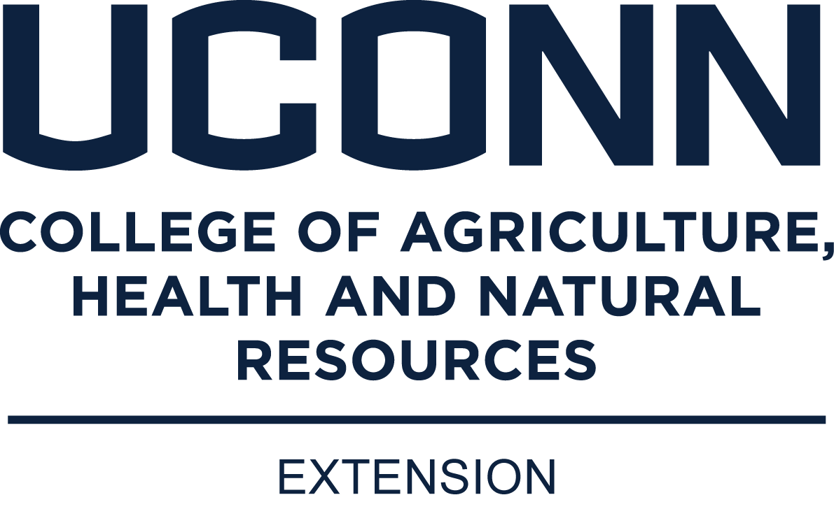
May 14, 2022
10:00 am
UConn Haddam Extension Center
Please fill out form by May 1, 2022

We are excited to announce that the UConn 4-H Horse Program is hosting a live and in person event! We are so very excited to see everyone! This event is free of charge but registration in advance is required.

For those new to the program, Giddy Up Games is a fun interactive program where teams of 2 participate in horse themed challenges and win prizes at the end of the day! There are two levels of participation, beginner and advanced.

This year’s Giddy Up Games will be happening OUTSIDE at the Extension Center in Haddam. If the weather is bad we will move inside. Once again you can team up with a friend – please indicate that when you register through the google form.

Please bring your own writing implement and clip board. We will likely need help this day – so idle parents/leaders should check in upon arrival to see if they can help.

If you are also doing Model Horse Show or Poster Contest, please follow the instructions and come well in advance to set up your displays.

Excited to see everyone on May 14th

Click Below to Enter – please fill out form by May 1, 2022
https://forms.gle/wPxgrwyfQ5Ztfn7L6

